Name ______________________

Date ______________Pd_____

Unit 1 - Worksheet 2: Energy Pie Charts

*Refer to your System Schemas in Worksheet 1 and your notes on the Activity 1 Observation Stations to help you recall and analyze each of these events.*

**Directions: For each Observation Station listed…**

1. Review your System Schema for the event from Worksheet 1.
2. Construct at least 3 labeled Energy Pie Charts for the following events you observed in the Activity 1 Energy Stations: one for the initial energy state, one for an intermediate state while the event is in progress, and one for the final energy state.
3. Under each energy pie, include a State Diagram *for events during which there is a change in configuration of the elements in your system*.
4. Label each segment of your energy “pies” with the way you think the system is storing energy. Please use “Esubscript” notation, where the subscript indicates the way you think the system stores energy. Explain your thinking!
5. Tumble Buggy

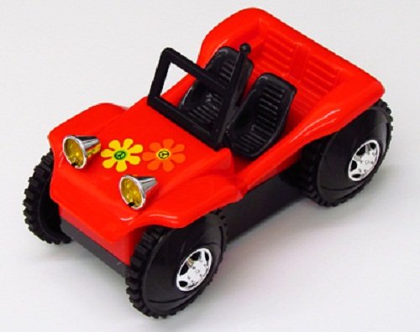

1. ****Wind-Up Toys
2. Air Puck



1. Ball Drop
2. Carts on a Track

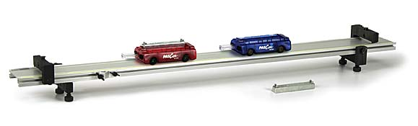

1. Watching Ice Melt
2. 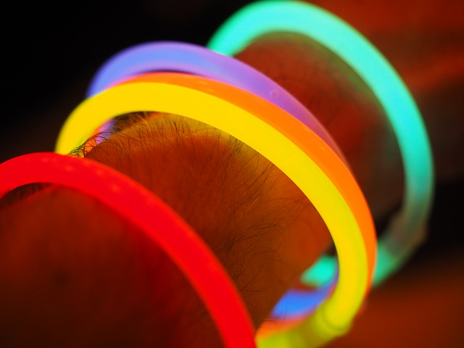Glow Sticks
3. ****Cheetos on Fire
4. 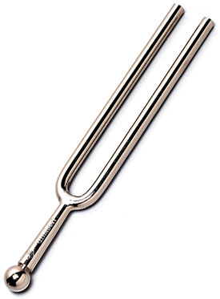Tuning Fork
5. Airzooka

